** ALINYIIKIRA JUNIOR SCHOOL - NAKWERO**

**BEGINNNING OF TERM III EXAMINATIONS 2024**

**AGE GROUP: 3 – 4 YEARS**

**CLASS: BABY**

**SUBJECT: ENGLISH (LA 2)**

NAME:……………………………………………………………………..……

1. **Match the same and write.**

g m _____

c d d

e g _____

m c _____

d e _____

1. **Ring the odd one out.**

 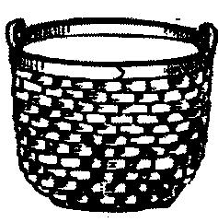 

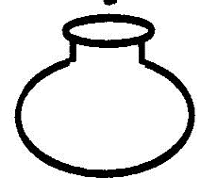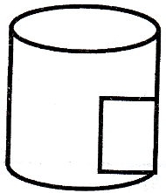 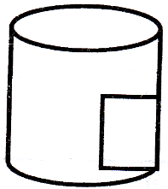

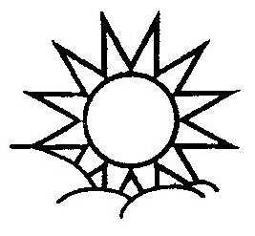 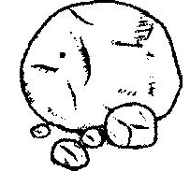 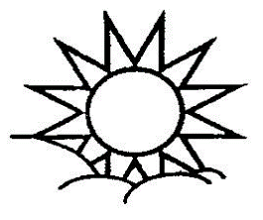

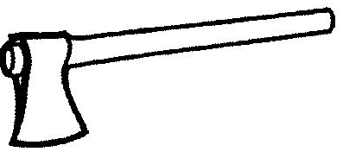  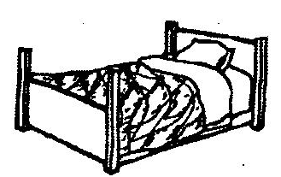

1. **Complete the pictures well.**

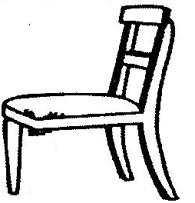 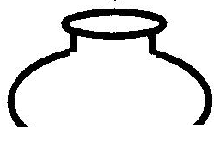 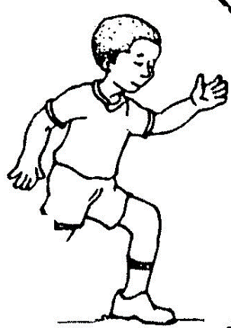

1. **Colour me well.**

